**PhelpsUSA.com | 1-800-344-7043**



**PROPOSAL**

OF SERVICES

Prepared for: {{ lead.businessname_cf }}

Prepared by: {% if lead.owner %}{% lead.owner.name %}{% endif%}

Date Prepared: {{ "now" | date: "%m/%d/%Y" }}

This proposal contains confidential information that shall not be disseminated by the Customer to any person or for any purpose except as may be necessary for the Customer’s evaluation thereof. The parties agree that this proposal creates no legal obligations for either party, and it is understood that Phelps The Uniform Specialists may modify or revoke the proposal at any time prior to both parties entering into a written Service Agreement. All pricing contained herein is valid for 30 days from the date on the cover of this proposal.

With Phelps, you’ll be gaining back time and energy to get back to what is really important: managing your business. If you find yourself answering yes to any of the following questions, it’s time to switch to Phelps!

**Am I having trouble getting a response from my current provider?**

**Is it taking too much of my time managing my uniform program?**

**Do I have billing inconsistencies or unexplained charges on my invoices?**

**Do I often have missed deliveries or shortages?**

**Am I unable to track the status of repairs or orders?**

**Do my uniforms come back looking dingy, wrinkled, or otherwise low quality?**

**Do I question whether my current provider is as efficient as they can be with their use of water and other resources?**

**Does my program seem "cookie cutter" and not particularly catered to my business?**

# What You’ll Get

There is a reason that Phelps has a **98% customer retention** **rate**. It’s because we know every business is different and needs a program that is customized specifically for them. Signing with Phelps means that you WILL receive the following:



**What You’re Missing**

WHY PHELPS?

**THE PHELPS DIFFERENCE**

The bottom line is that your company deserves professional-looking uniforms at the price

that you agreed to pay. With Phelps, you will always know the status of your garments and

where they are in the uniform process with no surprises on your statements or invoices.

**A company that has been family owned for over 40 Years.**

**RFID Garment Tracking and 100% Accuracy**

**Total Budget Program**

**A convenient Online Portal to review invoices, statements, and general requests**

**An easy-to-use App to submit repairs**

**Facility supplies, First Aid supplies, or Smart Clean services that can be easily added to your custom plan.**

**Online stores for both corporate apparel and facility supplies are available for employee convenience**

**A company committed to green, sustainable Technology and Processes**

# Your Full Service Partner

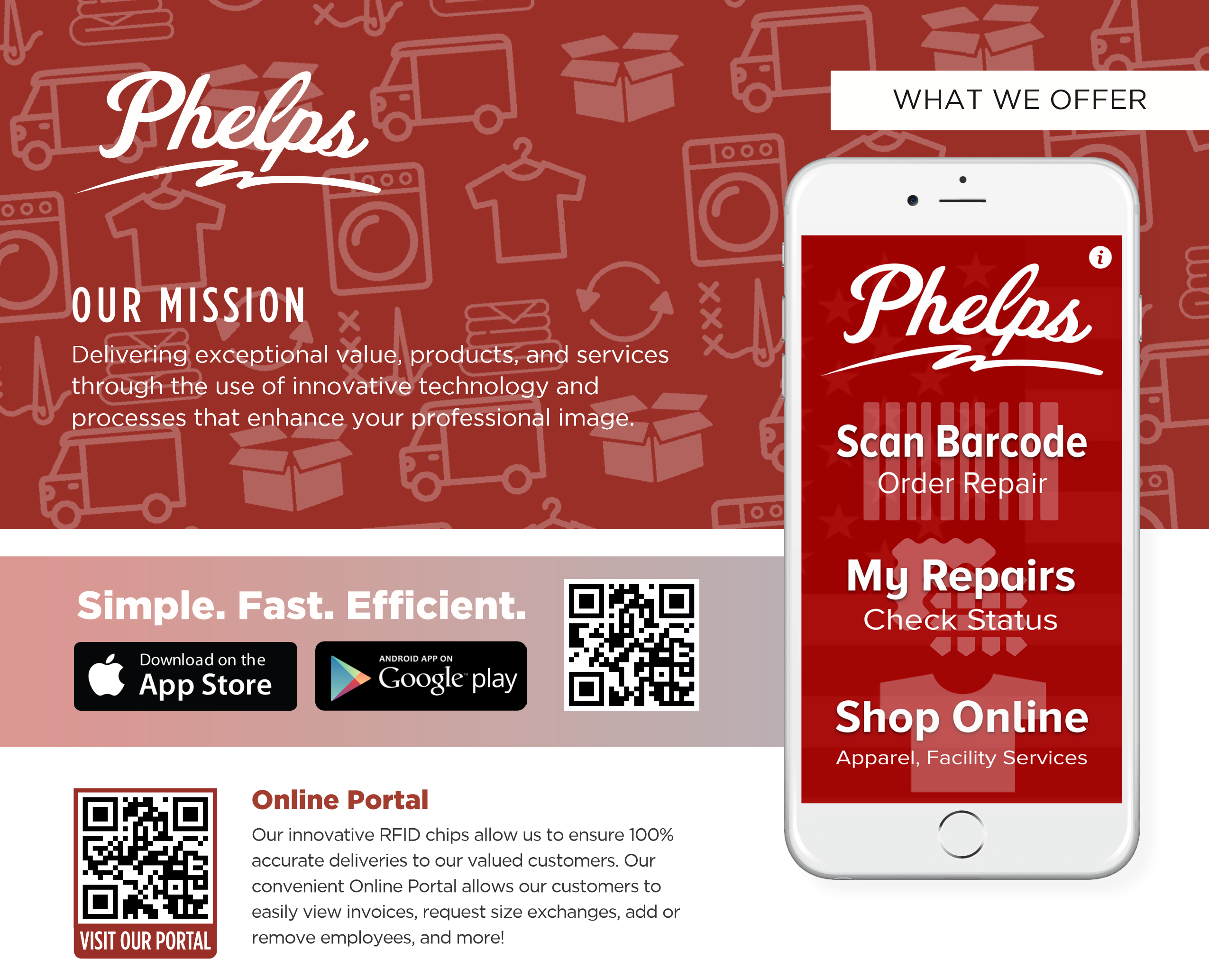Our vision is to be a single source for the highest-quality garments and textile rental services, facility services, custom apparel and personal protective equipment. Keep in mind, we would be happy to provide any of the following services down the road!



|  |  |  |
| --- | --- | --- |
| **Screen Printing**  **Embroidery**  **Promotional Products**  **Corporate or Team Apparel**  **Online Employee or Fundraising Stores**  **No Minimums on Embroidery** | **Restroom Cleaning Services**  **Custom Logo Mats**  **Janitorial Supplies**  **Restroom Supplies**  **First Aid** | **Flame Resistant High Visibility**  **Foot Protection**  **Hand Protection**  **Head/Ear/Eye Protection** |

{% assign fgsubtotal = 0 %}

|  |  |  |  |  |
| --- | --- | --- | --- | --- |
| **Phelps Garment Program** | **Unit Cost** | **Inv/User** | **# of Users** | **Delivery Total** |
| **{% for p in purchases %}{{p.purchasable.name}}{% assign rowtotal = prinv | times: p.users_cf %}{% assign gbsubtotal = gbsubtotal | plus: rowtotal %}** | **{{p.price | currency }}** | **{{ p.invuser_cf }}** | **{{p.users_cf}}** | **{{rowtotal | currency }}{% endfor %}** |

|  |  |  |  |
| --- | --- | --- | --- |
| **Flat Goods** | **Unit Cost** | **# of Units** | **Delivery Total** |
|  |  |  |  |

{% assign total = gbsubtotal | plus: fgsubtotal %}

|  |  |
| --- | --- |
| **Estimated Delivery Total:** | {{total | currency}} |

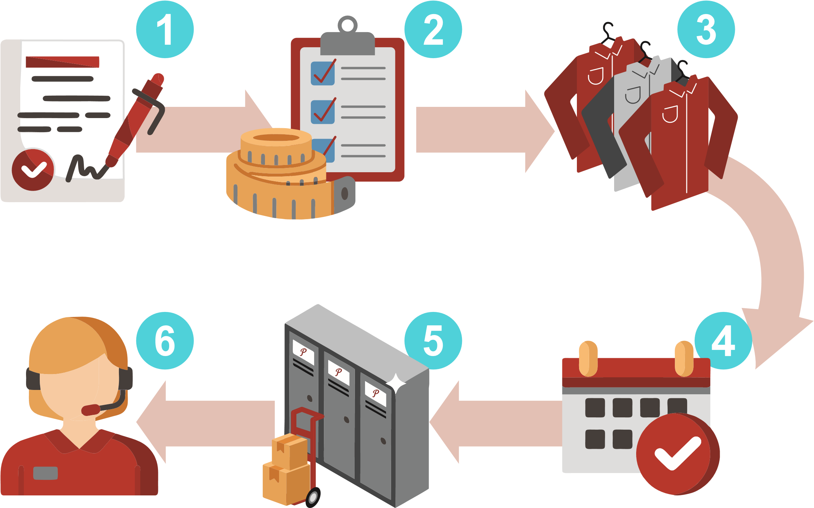



INSTALLATION TIMELINE

**OUTFITTING**

YOUR COMPANY

|  |  |
| --- | --- |
| 1. **Complete and Sign Agreement**   **Documents:** First, we’ll complete all paperwork for your agreement   1. **Sizing and Inventory Level**   **Confirmation:** A Phelps representative will pay your business a visit to conduct sizing and confirm quantities for delivery   1. **Order Uniforms:** Next, we’ll order your uniforms and decorate them with your company emblem | 1. **Schedule and Confirm Installation Date:**   Our customer service team will call your business to schedule and confirm an initial delivery date   1. **Complete Initial Install:** Today is the day!   A Phelps Representative will arrive with everything you’ll need for your uniform program. This includes soil lockers, the first round of uniforms, mats, etc.   1. **Customer Satisfaction Call:** Our customer   service team will call to make sure install went perfectly and to see if your business needs to make any adjustments to your inventory |

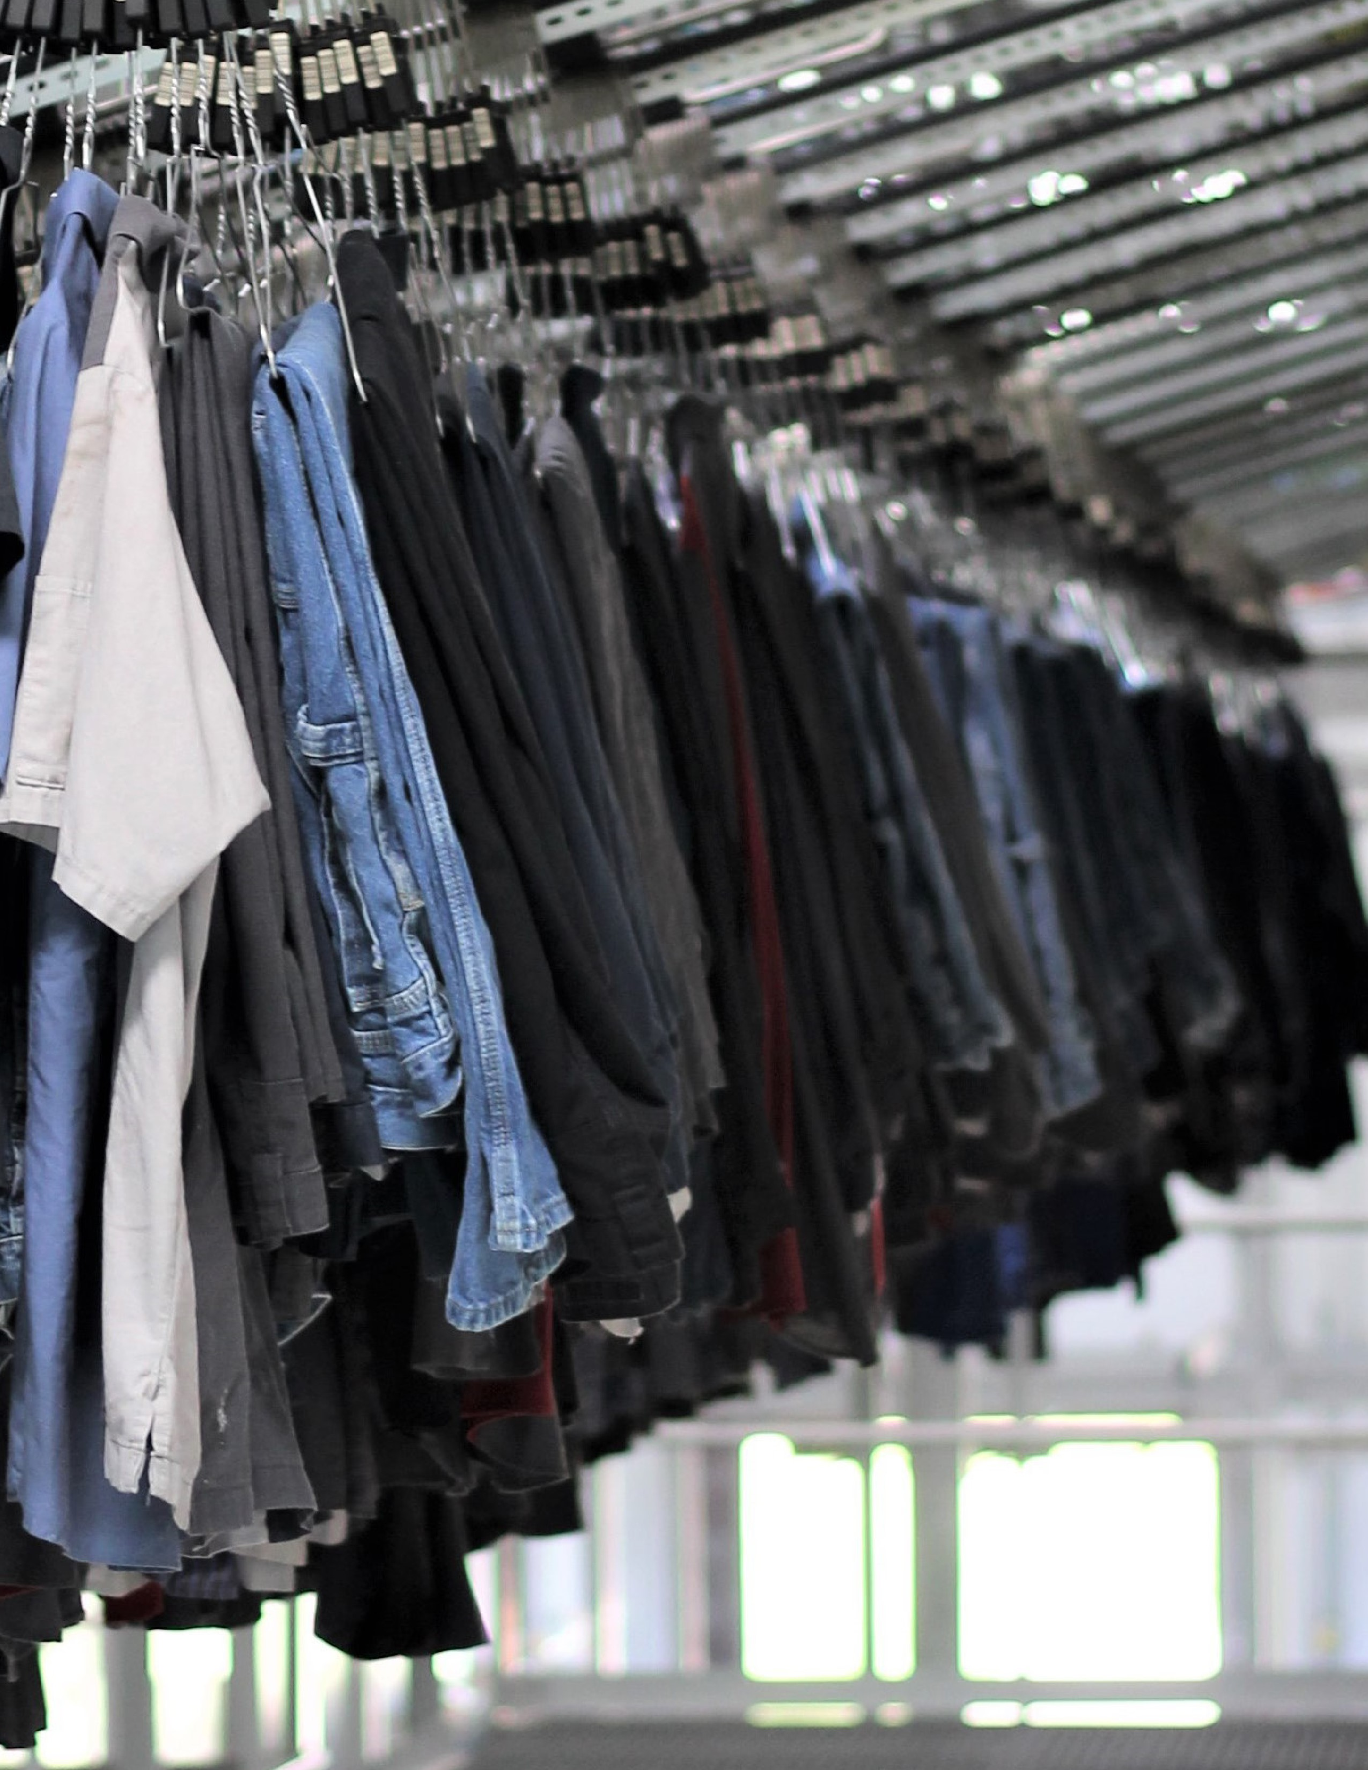

**PhelpsUSA.com | 1-800-344-7043**

**FAMILY OWNED AND OPERATED SINCE 1981.**

**We Look Forward to**

**Working with you!**